
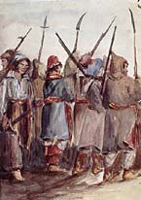
La Patriote
#10
Mike Ford
from the album “Canada Needs You - vol. 1”
MapleMusicRecordings

Vocabulary and Translations

- assimilation -

- cholera -

- defections -

- eloquence -

- flatulence -

- fraudulence -

- noose -

- white flags -

- Les Fils de Liberte -

- Mille-Huit-Cent-Trente-Quatre -

- Suivez La Patriote -

- La belle espore, le beau risqué de la nation Canadienne -

Do You Know It?

- Who were the “Patriotes”?
- Who was Papineau?
- What was the Chateau Clique?
- What is a “habitant”?
- Who were the “Les Fils de Liberte”?
- What is meant by “Van Deiman’s Land”?

49

Who are the Patriotes opposed to?

Beyond the political problems, what hardships are the people of Lower Canada facing?

Who takes up the cause of the Patriotes, and leads a “war of words”?

Where were the three battles of the rebellion located? (Hint: the three towns were named after “saints”)

What did the English soldiers do at Ste Eustache that forced the Patriotes to surrender?

Did You Catch It?

Do You Get It?
- Who is “she”? Why do you think the writer chose “she”?

- What are some of the consequences of the Rebellion?

- Explain why are loyal men of the War of 1812 now being hung?

- What 2 options are being posed to the people of Lower Canada in the first stanza (lines 5 - 6)?

Activities and Extensions!

Create a flyer that is two sided. On one side, promote propaganda that is militant. On the other side, promote propaganda that is passive.



Teacher’s Guide

BACKGROUND INFORMATION

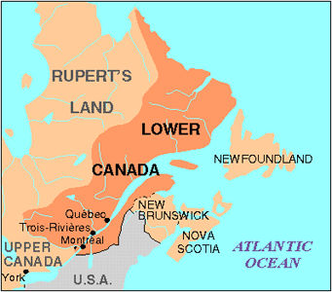
The Rebellions of 1837 took place in both Upper and Lower Canada. In Lower Canada the rebellion was in large part an expression of a resurgent French Nationalism. The French Canadian majority constituted the overwhelming majority in the locally elected Assembly established by the Canada or Constitutional Act, 1791. Though peaceful means were sought initially to overcome the abuse of power, by 1837 the unrest turned to violence.

ANSWER KEY

“Do You Know It?”

- The Patriotes were whose who want responsible government in Lower Canada
- Papineau was a member of the upper class who believes in responsible government
- The Chateau Clique was an exclusive group of appointed Tory leaders who ran Lower Canada
- A habitant is a farmer in Lower Canada
- “The Sons of Liberty”, were mostly young men who opposed the Chateau Clique
- Van Deiman’s land meant you were sent into exile

“Did You Catch It?”

- The Patriotes were opposed to the Governeur and the Chateau Clique
- Other hardships of the time included poor crops and cholera
- Papineau (Louis-Joseph) takes up the Patriotes cause
- The three main battles of the rebellion took place at St Denis, St Charles, and Ste Eustache
- At Ste Eustache, the English soldiers set fire to buildings to force the Patriotes out

“Did You Get It?”

- Answers will vary
- Some Patriotes were bound in chains (arrested), hanged, or exiled (Van Deiman’s Land)
- Some of the Patriotes fought with the British against the Americans, but now they were fighting the British because of the political injustices that they faced.
- The Patriotes’ two options were to keep fighting with words or become militant

ADDITIONAL RESOURCES

Suggested Reading:
P.A. Buckner, The Transition to Responsible Government: British Policy in British North America 1815-1850 (1985); G. Craig, Upper Canada (1963); Jacques Monet, The Last Cannon Shot (1967); Desmond Morton, Rebellions in Canada (1979); F. Ouellet, Social and Economic History of Québec (tr 1980) and Lower Canada 1791-1840: Social Change and Nationalism (1980); Colin Read, The Rising in Western Upper Canada (1980); Read and Ronald J. Stagg, The Rebellion of 1837 in Upper Canada (1985); Elinor Kyte Senior, Redcoats and Patriotes: The Rebellions in Lower Canada 1837-38 (1985). Source: www.thecanadianencyclopedia.com

